**Google Drive mount and data file read in Colab:**

**Step 1:** Login to Google Colab account

**Step 2:** Add below code in the executable box and click run button

**from google.colab import drive**

**drive.mount('/content/drive')**

**Refer below screenshot:**

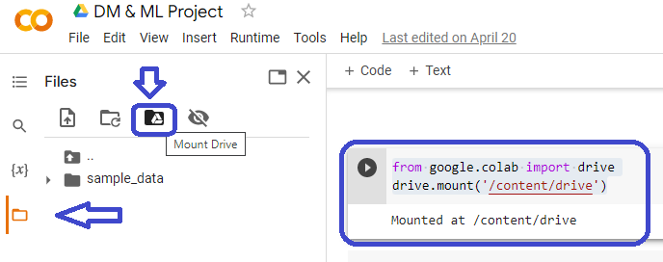

**Step 3:** Allow permission to access Google drive

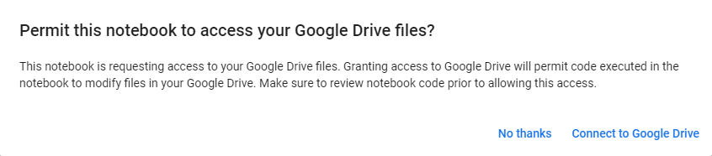

**Step 4:** Once granted permission, mount the drive as mentioned in blue arrows from the above screenshot and click refresh as mentioned in below screenshot. A drive will be mounted and appear.

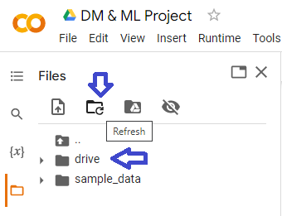

**Step 5:** Navigate to the path of test and train data file in the drive, right click on the file and select “Copy Path”. Open main.py file and paste the path in the main.py code to the respective gene_train and gene_test variables.

**#Data File read**

**gene_train = pd.read_table(r"/content/drive/MyDrive/Clustering_competition_1/data_tr.txt", header=None)**

**gene_test = pd.read_table(r'/content/drive/MyDrive/Clustering_competition_1/data_ts.txt', header=None)**

**Step 6:** Copy the entire code from main.py and paste it in the colab new executable box and click run.

**Step 7:** Result will shown up.